|  |
| --- |
| Coursera Capstone Project report |

Introduction 2

Data 4

Methodology 5

Results 9

Conclusion 9

# Introduction

The Mayor of Mississauga has floated a RFP for finalizing the location for an Italian restaurant in Port credit area.

They wanted analysis of the existing business and particular restaurants to ensure Italian restaurant would indeed be successful.

Aruna Dorai Inc was one of the shortlisted agencies to be invited to present a proposal to address this problem.

Aruna Dorai Inc was an acclaimed consulting agency using Data science and Machine learning for all their projects. They have a proven track record of success. They keep up with the latest trends in Data and information management.

They have a proven solutioning process for informative problem solving.

The above-mentioned process was followed to address this problem.

**Who can use this report ?**

This report is specifically created for the Mississauga mayors office, however can be used by zoning officers or new small businesses trying to enter the market in the south Mississauga (Port Credit) neighborhood.

Port Credit neighborhood is one of the affluent communities with beautiful custom homes and manicured gardens. The demographic is mostly double income families and has discretionary amount for going to restaurants.

|  |
| --- |
|  |

# 

# a Snapshot of Canadian populations and key nuances.

# Data

Various data sources were used to do this analysis.

For the Jupyter notebook, the Coursera previous lessons, Github and python documentation was used.

1. Data source world cities and no of restaurants by population
   1. URL -

<http://www.worldcitiescultureforum.com/data/number-of-restaurants-per-100.000-population>

1. Mississauga population and employment data
   1. URL –

<http://www7.mississauga.ca/documents/pb/opendata/2019/P_10_2019EmploymentProfileFinal.pdf>

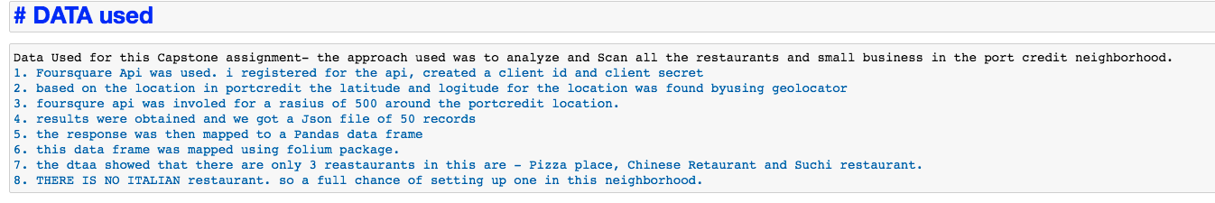

# Methodology

1. Data of Mississauga was analyzed using various data sources.
2. Population, it Affluence decides demands on restaurants in an area.
   1. As you can see 1747 Food Services exists in this area.
   2. 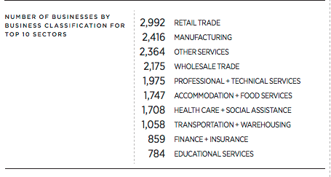
   3. 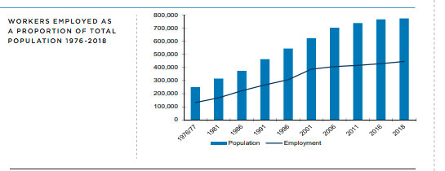
3. Using the Ratio of people to restaurants, Toronto’s average was 1904. Where as Mississauga fell short on that scale at 1747.
4. It does prove that we can Add more restaurants in this area.
5. Using the Foursquare api we mapped the businesses in this neighborhood. 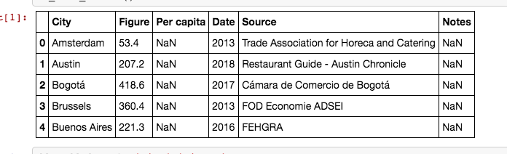
6. 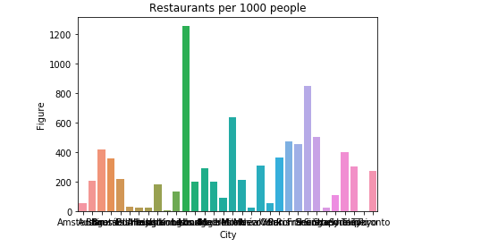
   1. 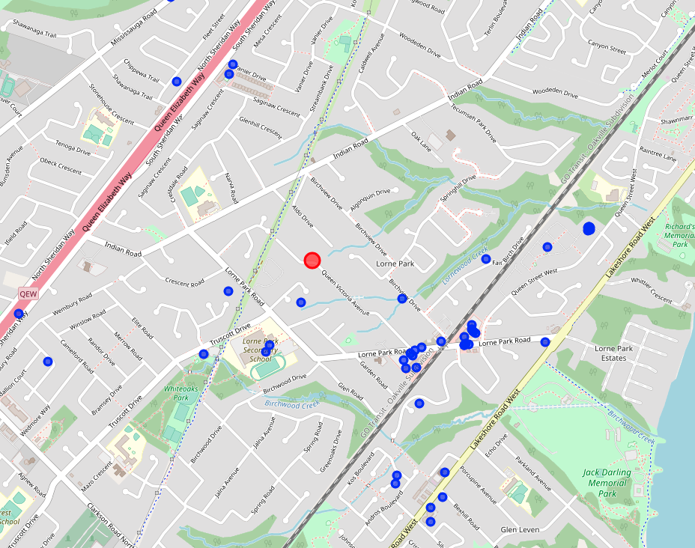
   2. in the surrounding area of the RED dot there were only 3 eateries.
   3. 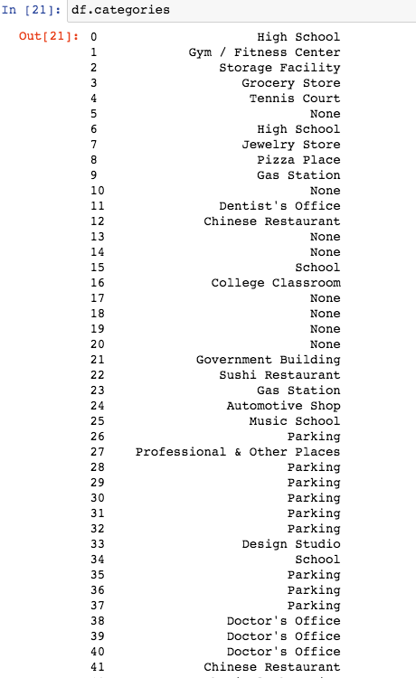

8 – Pizza place, 22 – Suchi restaurant, 41 – Chinese Restaurant

***There is definely room to add an italian restaurant.***

# Results

As seen in this report above the Mayor is advised to approve the restaurant and proposedItalian would be perfect for the neighborhood.

Proposed location – ***1300 Queen Victoria Avenue, Mississauga, L5H3H2***

Applied data science was very useful to help arrive at this conclusion.

# Conclusion

The Mayor of Mississauga has taken the recommendation and construction is underway as we submit this report. Once again Aruna Dorai inc has been successful in their consulting services using Data science principles. This indeed is another feather in their cap.